**Project Definition**

There are thousands of mobile applications to find a friend. However, none of these applications are designed to make a real fellowship. The purpose of these apps is to match people according to the looks they like, and it is not making friends, it is to find a partner. In this mobile application, we will develop an application to make a real friendship according to hobbies and common interests

**System Requirements**

• Server:

o Register

o Login

o Create Event

o Join Event

• Client:

o List Upcoming Events

o List Created Events

o List Past Events

o See The Details of Event

o Join to The Event

o Create a New Event

o Select the Category of Event

**System Architecture**

**Use Cases**

1. **Register:** User fills required information and clicks the register button. App sends a request to create a new user to our database and if the response is true the user gets a success message.
2. **Login**: User fills required information and clicks the login button. App sent a request to check username and password from database and if it is correct send a token response and navigate to main page
3. **Check Activity**: App sends a get request to database and shows response in a page.
4. **Join Activity**: User clicks to an event and sends a request to join to the event.
5. **Create Activity**: User fills required parts of form and sends a request to create new activity in the database. If everything is valid, the user gets a success message.

**Use Case Diagram**

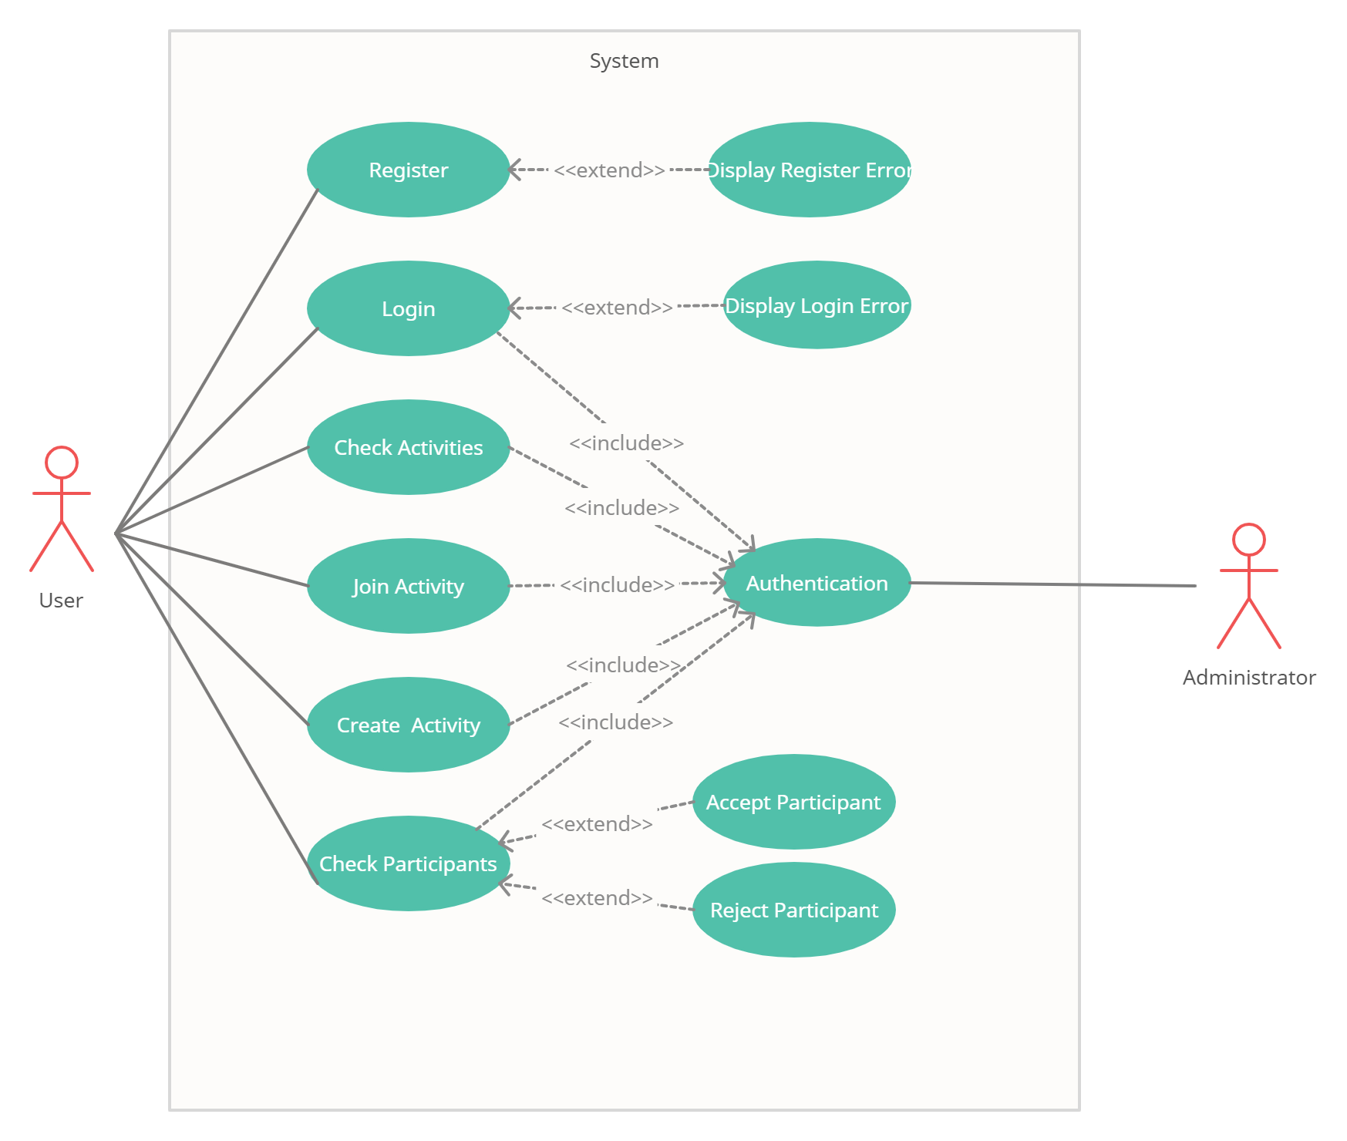

**Architectural Design**

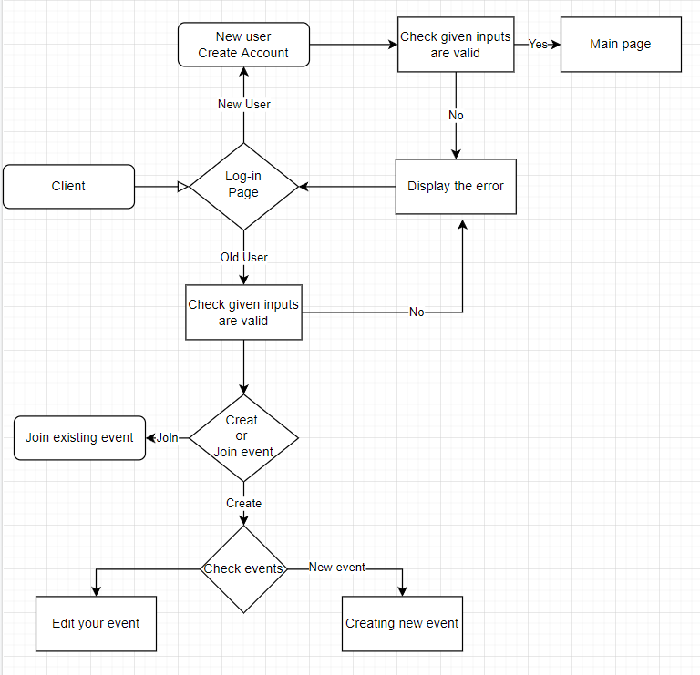

**APIs**

* **https://localhost:3000/login - POST**
* **https://localhost:3000/register - POST**
* **https://localhost:3000/categories - GET**
* **https://localhost:3000/createEvent - POST**
* **https://localhost:3000/events - GET**
* **https://localhost:3000/myEvents - GET**
* **https://localhost:3000/pastEvents - GET**
* **https://localhost:3000/join - POST**

**Database Architecture**

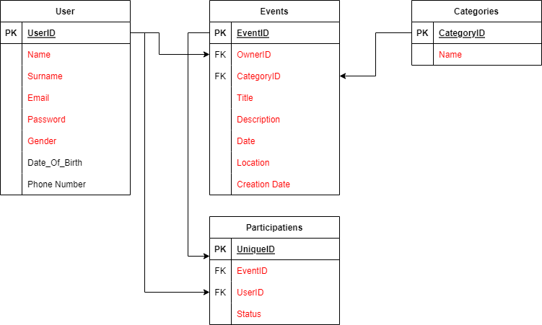

**Database Tables**

**Category**

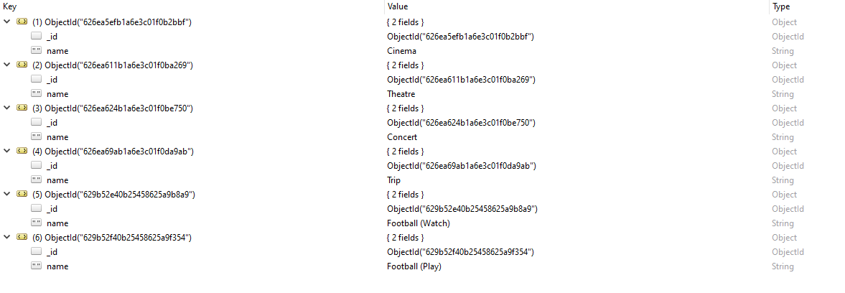

**Eventmetin içeren bir resim

Açıklama otomatik olarak oluşturuldu**

**Users**

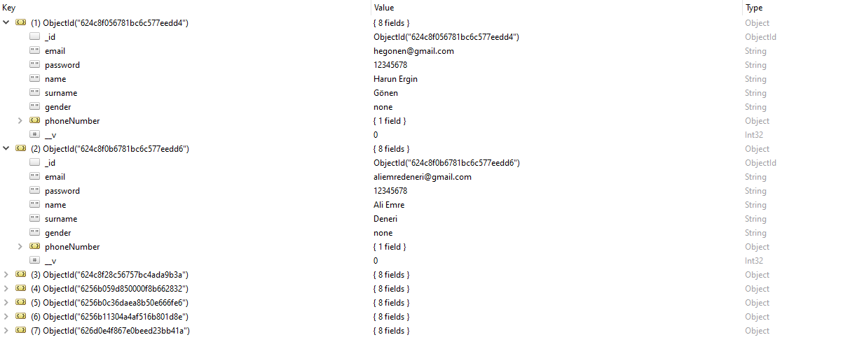

**SCREENS**

**Login Screen Register Screen**

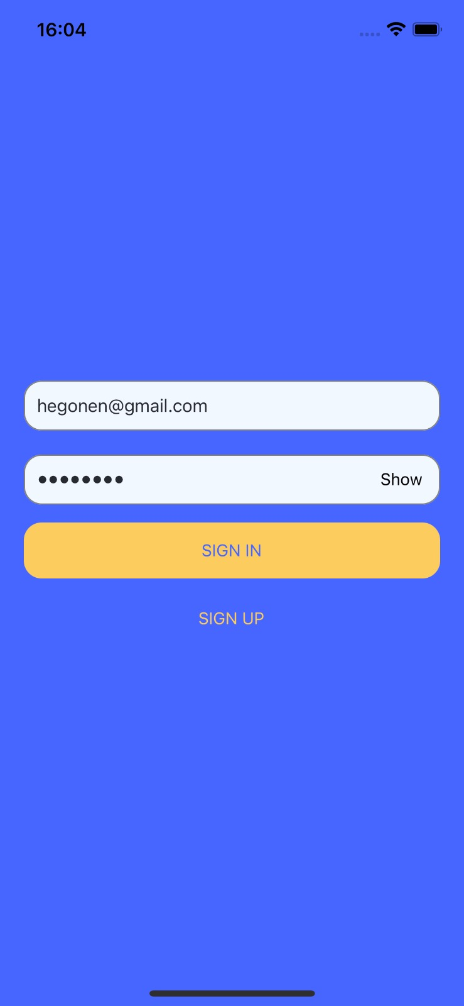 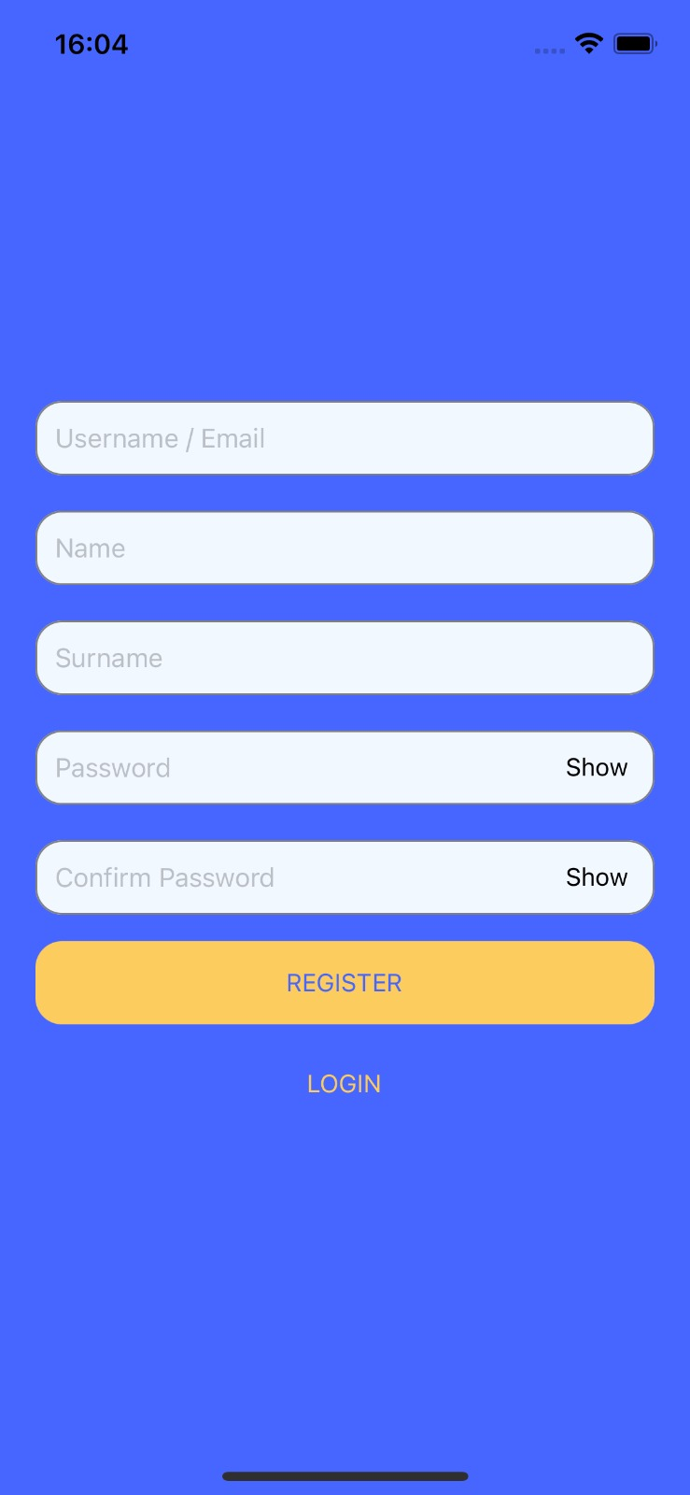

**Home Screen**

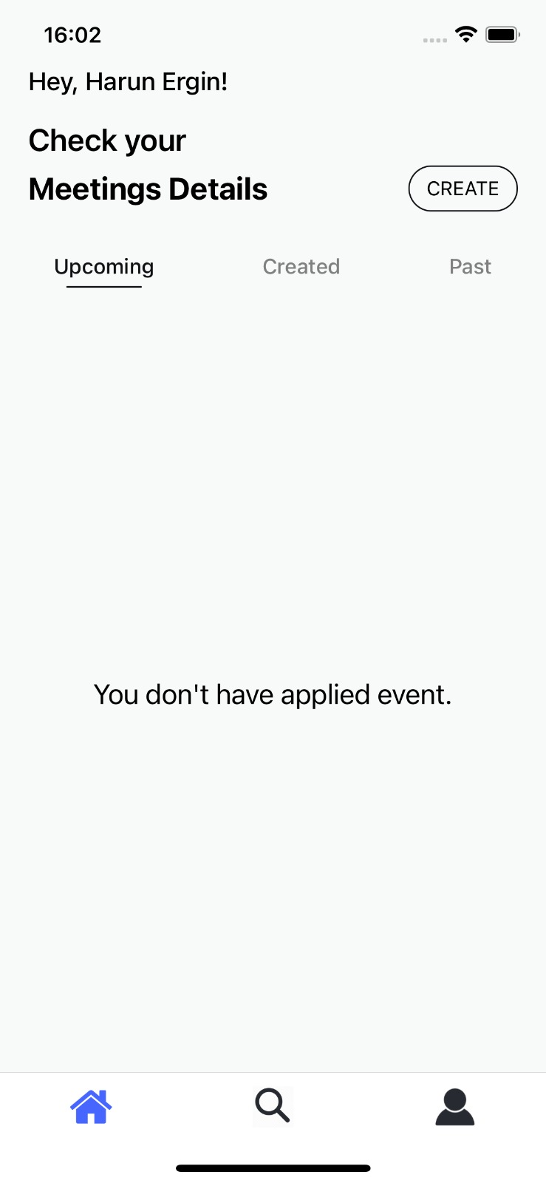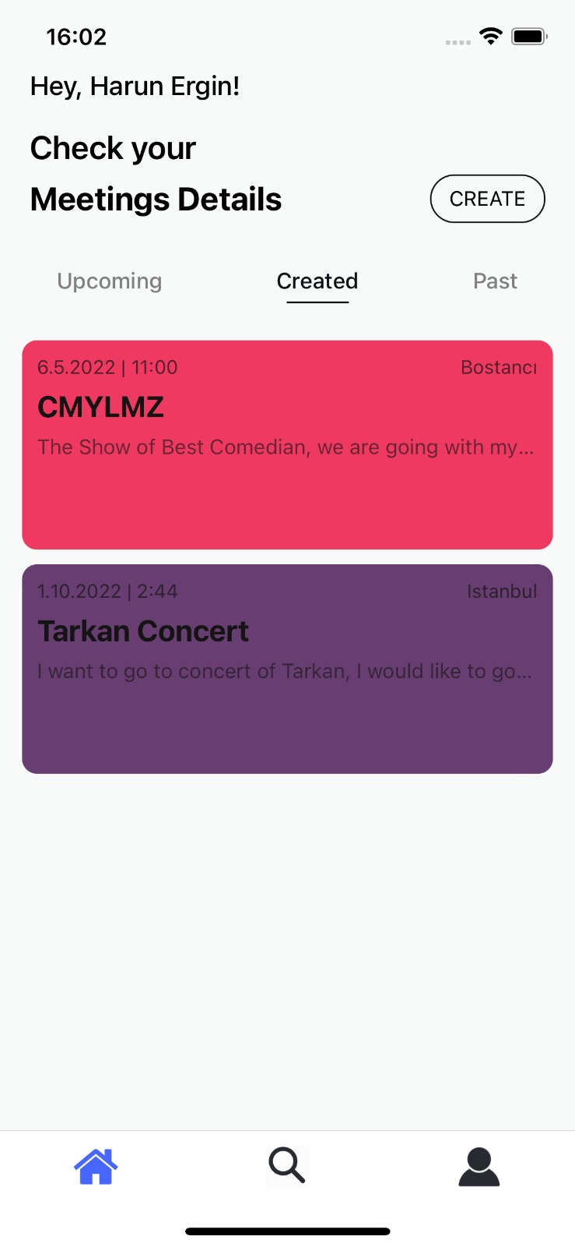

**Create Event Screen Event Details Screen**

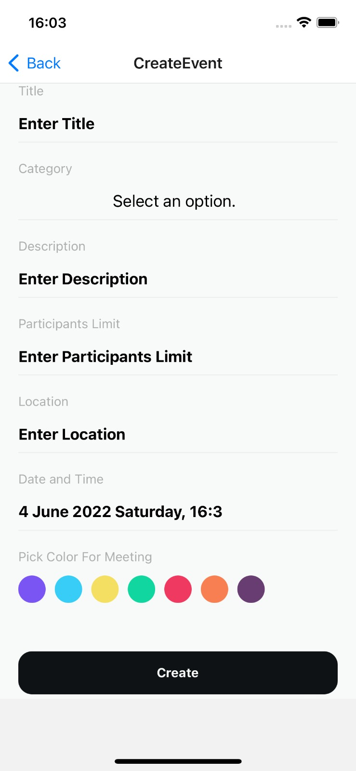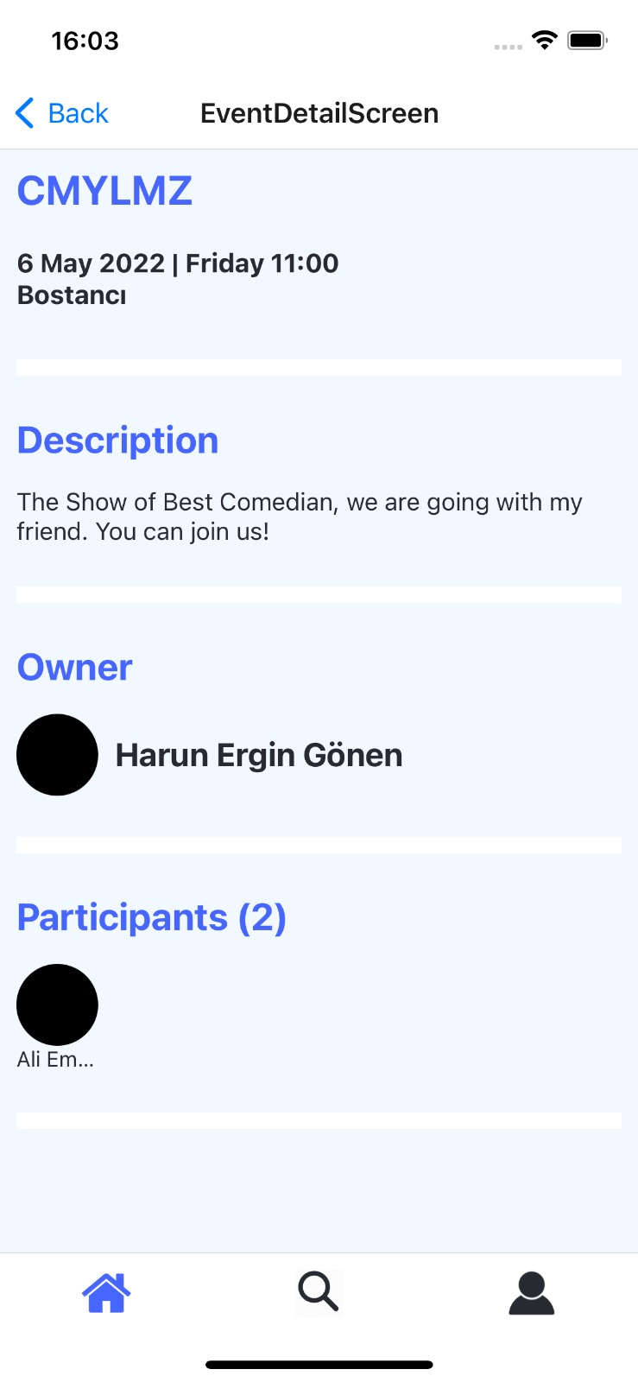

**Search Events Screen Sorting Sheet Open**

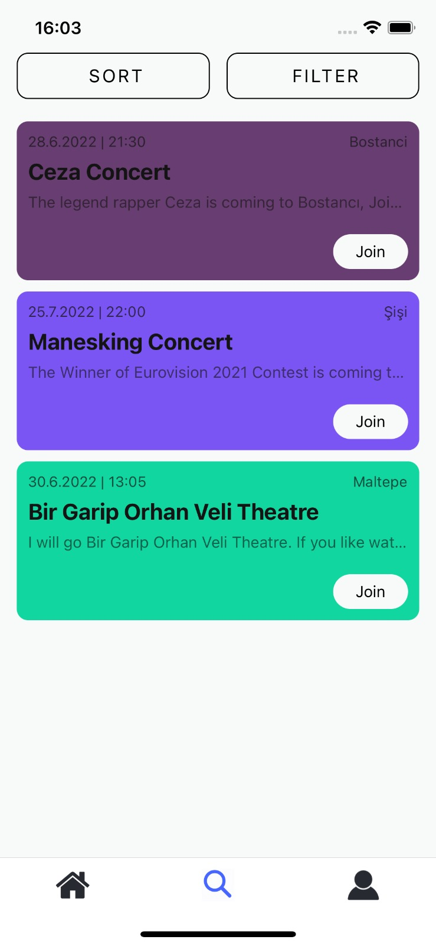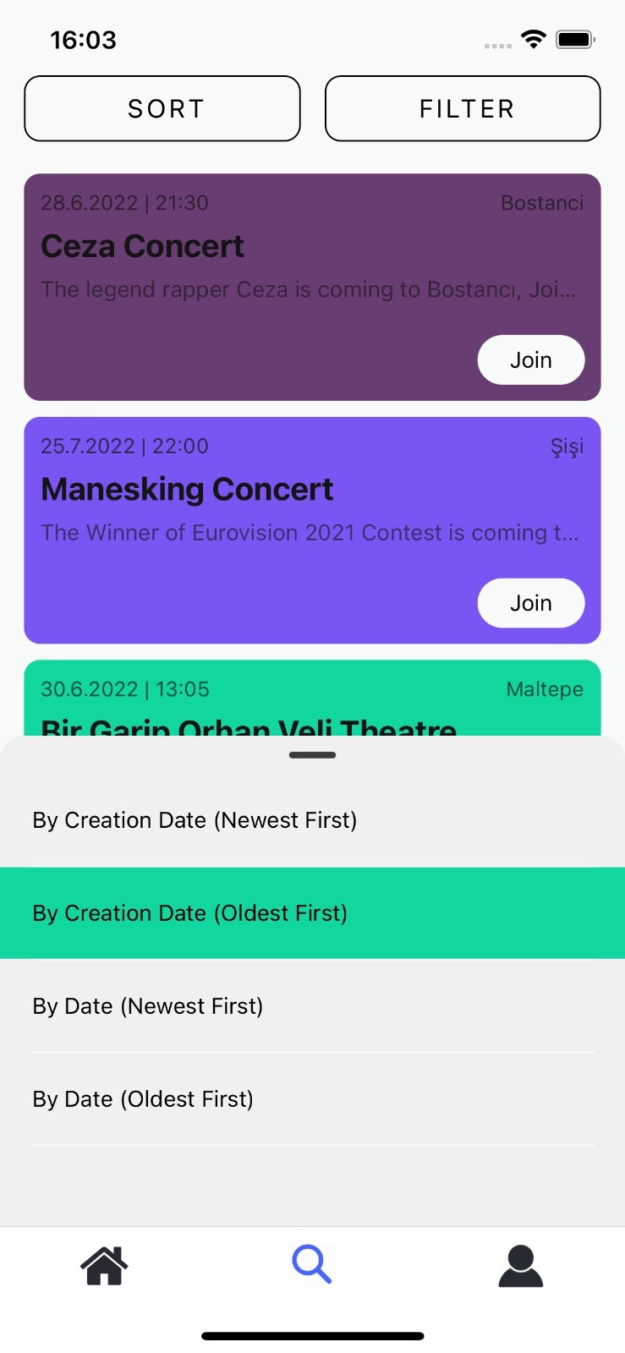

**Profile Screen**

